AI Assistant Lab-9.4
2303A52335
V. Rachana
Task 1: Auto-Generating Function Documentation in a Shared
Codebase
Scenario
You have joined a development team where several utility functions are
already implemented, but the code lacks proper documentation. New
team members are struggling to understand how these functions should
be used.
Task Description
You are given a Python script containing multiple functions without any
docstrings.
Using an AI-assisted coding tool:
• Ask the AI to automatically generate Google-style function
docstrings for each function
• Each docstring should include:
o A brief description of the function
o Parameters with data types
o Return values
o At least one example usage (if applicable)
Experiment with different prompting styles (zero-shot or context-based)
to observe quality differences.
Expected Outcome
• A Python script with well-structured Google-style docstrings
• Docstrings that clearly explain function behavior and usage
• Improved readability and usability of the codebase

Prompt: Generate Google-style docstrings for the following Python functions.
Include:
- Brief description
- Args with data types
- Returns section
- Example usage
Code:
def add(a, b):
return a + b
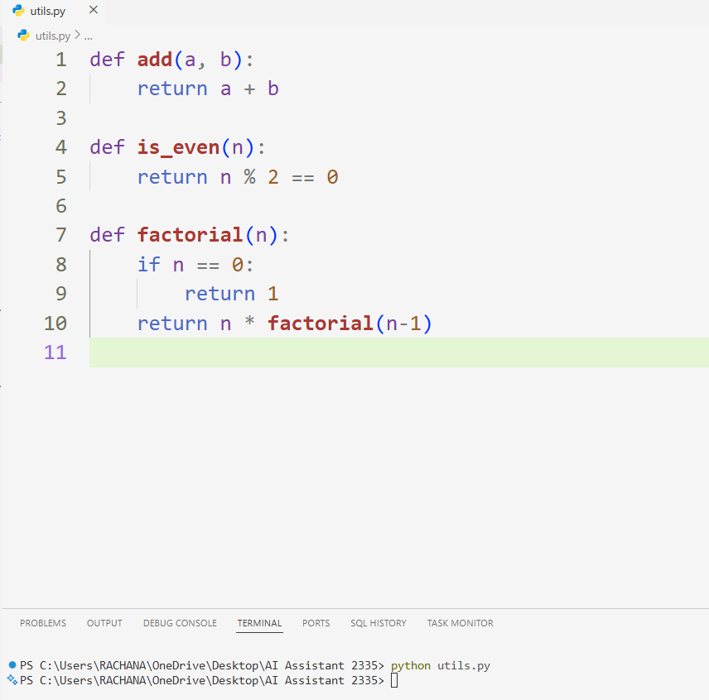

Example prompt to AI:
Generate Google-style docstrings for these Python functions.
Include:
- Description
- Args with data types
- Returns
- Example usage
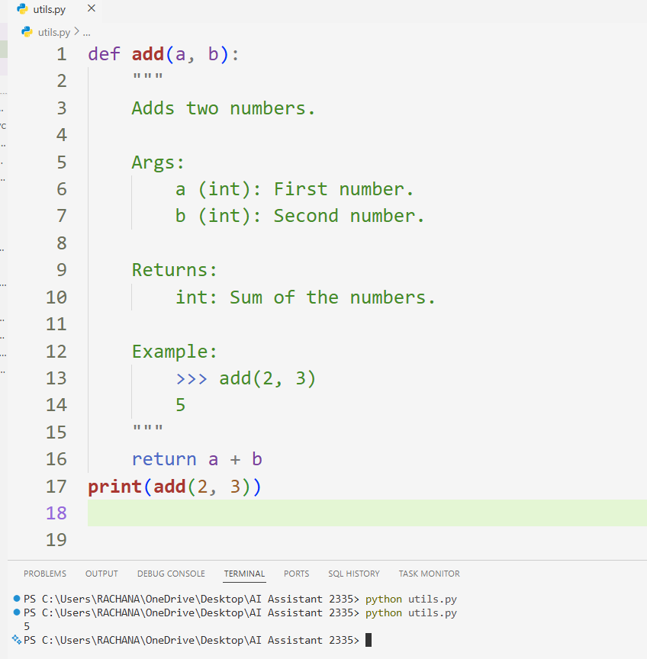
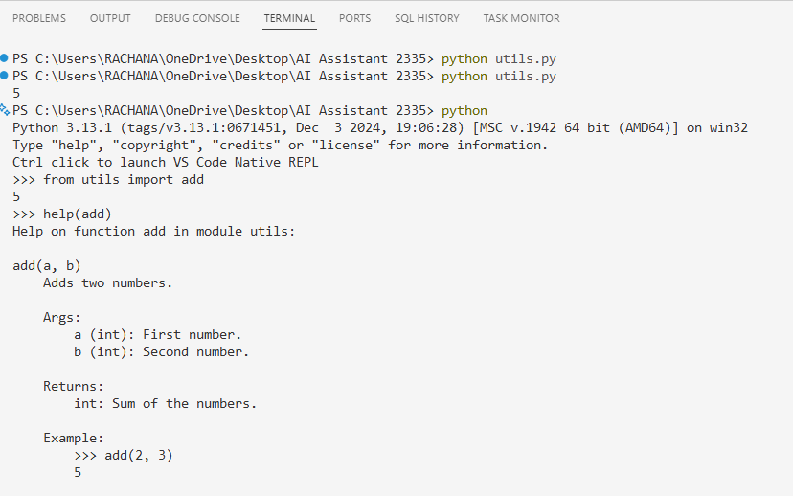
Observation:
- The AI tool successfully generated Google-style docstrings automatically for the given function.
- The generated documentation included:
  - Function description
  - Parameters with data types
  - Return value explanation
  - Example usage
- Zero-shot prompting produced basic documentation.
- Context-based prompting produced more detailed and professional documentation suitable for team environments.
- After adding the generated docstrings, code readability improved significantly.
- The function executed correctly and produced the expected output.
- Using help(add) displayed the generated documentation properly, confirming correct implementation
Task 2: Enhancing Readability Through AI-Generated Inline
Comments
Scenario
A Python program contains complex logic that works correctly but is difficult to understand at first glance. Future maintainers may find it hard to debug or extend this code.
Task Description
You are provided with a Python script containing:
• Loops
• Conditional logic
• Algorithms (such as Fibonacci sequence, sorting, or searching)
Use AI assistance to:
• Automatically insert inline comments only for complex or non-
obvious logic
• Avoid commenting on trivial or self-explanatory syntax
The goal is to improve clarity without cluttering the code.
Expected Outcome
• A Python script with concise, meaningful inline comments
• Comments that explain why the logic exists, not what Python
syntax does
• Noticeable improvement in code readability
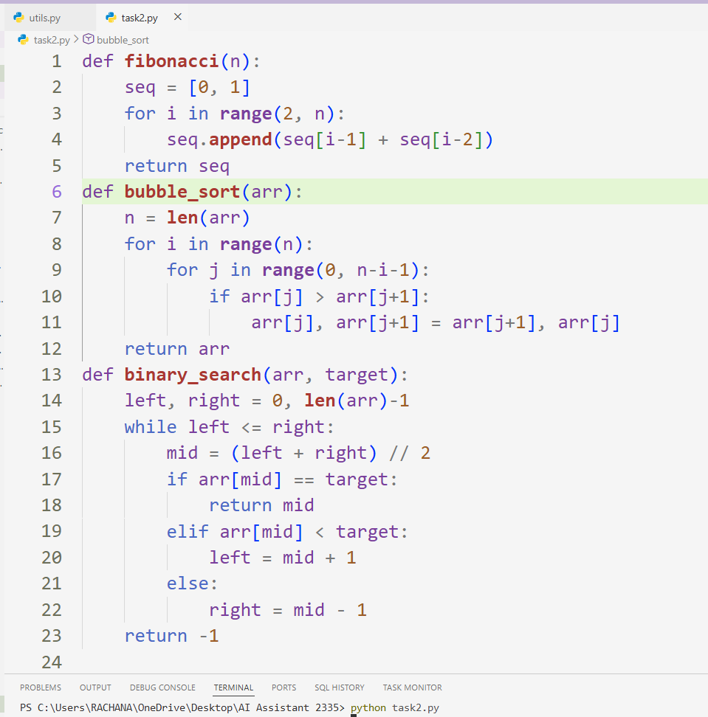
Prompt:
Add meaningful inline comments to this Python code.
Rules:
- Add comments only for complex or non-obvious logic
- Explain WHY the logic exists, not basic Python syntax
- Avoid unnecessary comments
- Improve readability without clutter
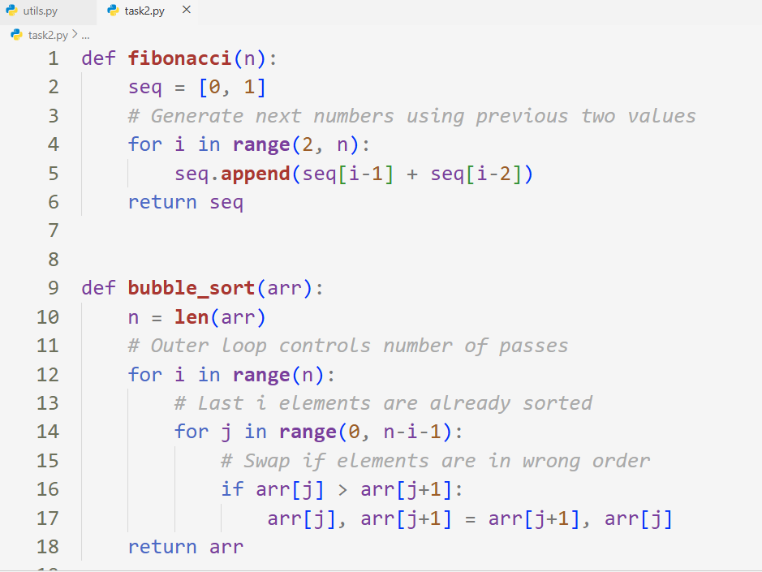
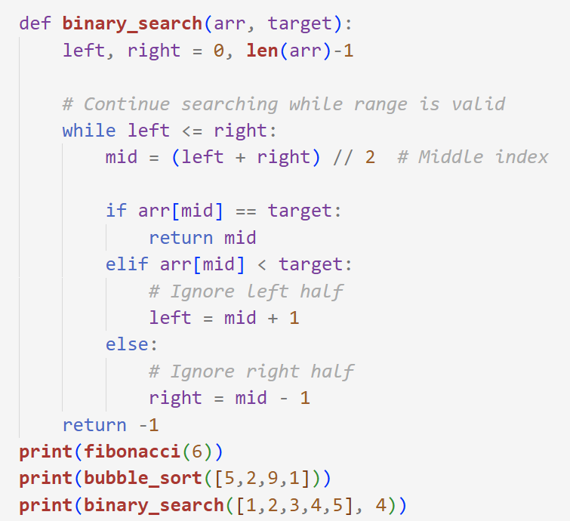
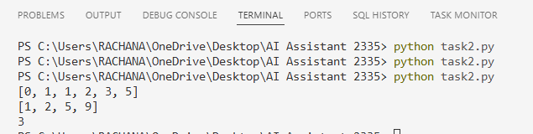

Observation:
- AI successfully inserted inline comments for complex logic only.
- Comments explained the reasoning behind loops and conditions.
- Trivial syntax was not commented, preventing clutter.
- Algorithms like Fibonacci, Bubble Sort, and Binary Search became easier to understand.
- Code readability improved without affecting execution.
Task 3: Generating Module-Level Documentation for a Python
Package
Scenario
Your team is preparing a Python module to be shared internally (or
uploaded to a repository). Anyone opening the file should immediately
understand its purpose and structure.
Task Description
Provide a complete Python module to an AI tool and instruct it to
automatically generate a module-level docstring at the top of the file
that includes:
• The purpose of the module
• Required libraries or dependencies
• A brief description of key functions and classes
• A short example of how the module can be used
Focus on clarity and professional tone.
Expected Outcome
• A well-written multi-line module-level docstring
• Clear overview of what the module does and how to use it
• Documentation suitable for real-world projects or repositories
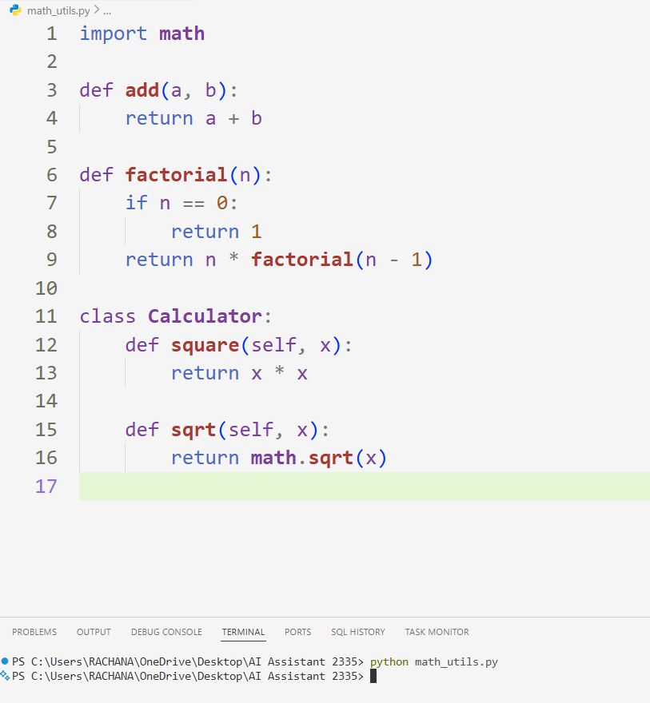
Prompt
Generate a professional module-level docstring for this Python module.
Include:
- Purpose of the module
- Required libraries or dependencies
- Brief description of key functions and classes
- Short example usage
Use clear and professional tone suitable for a real-world repository.
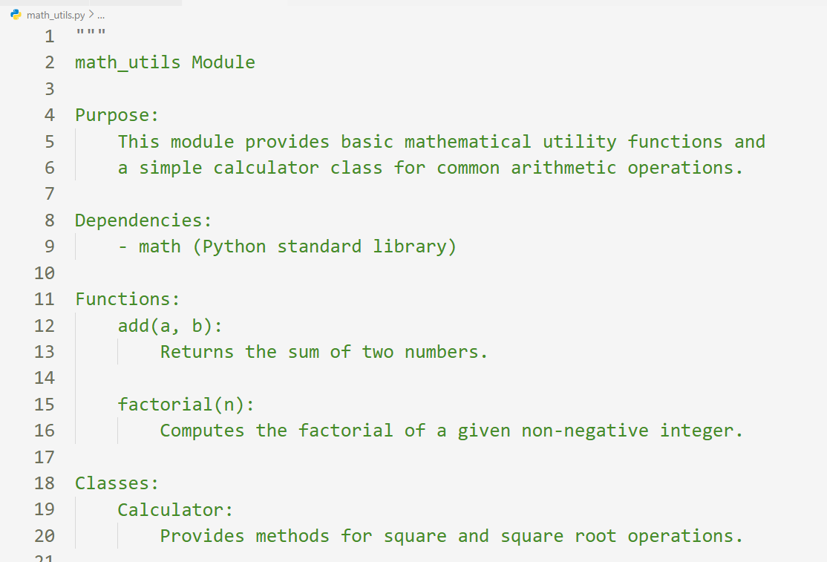
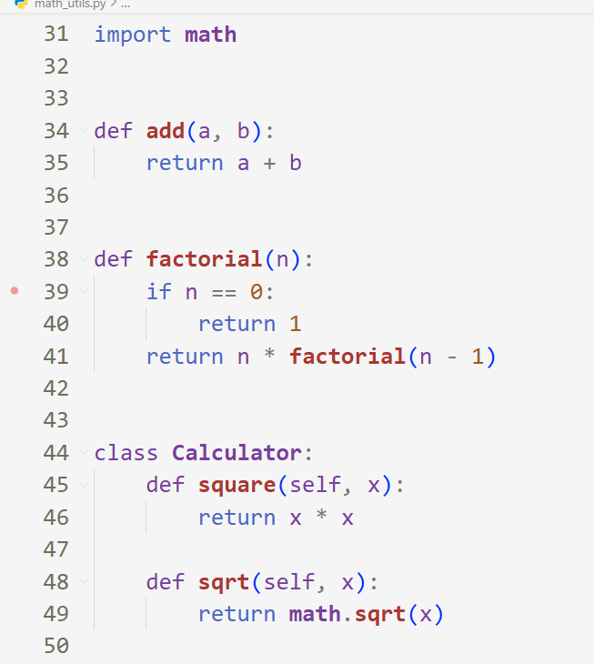
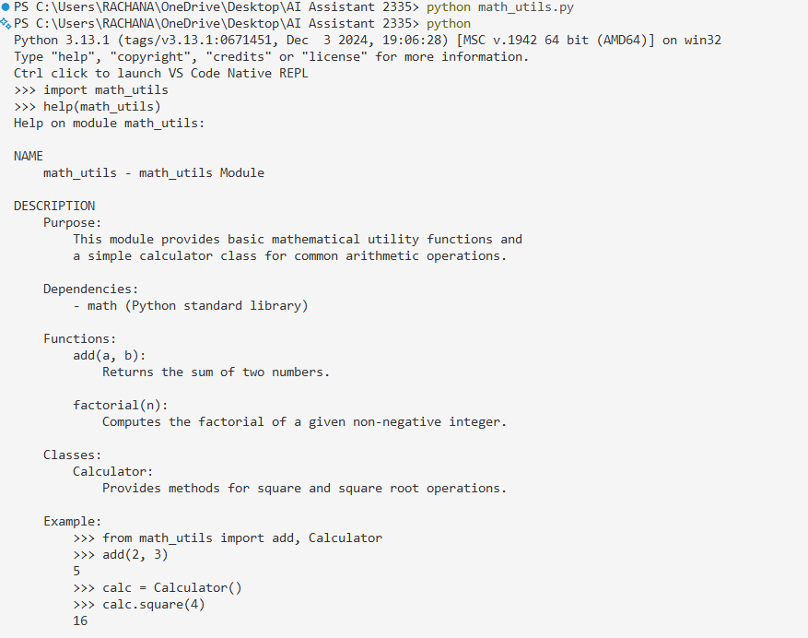
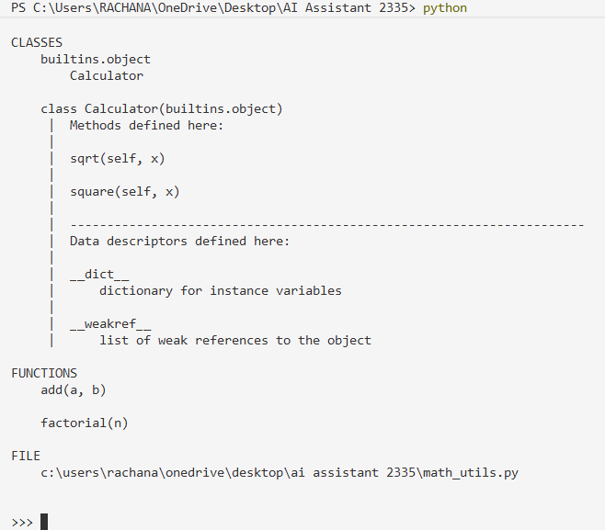
Observation:
- AI successfully generated a structured module-level docstring.
- The docstring clearly explained the module purpose and dependencies.
- Key functions and classes were summarized briefly.
- Example usage helped understand how to use the module quickly.
- Documentation improved readability and made the module suitable for sharing in repositories.
Task 4: Converting Developer Comments into Structured Docstrings
Scenario
In a legacy project, developers have written long explanatory comments
inside functions instead of proper docstrings. The team now wants to
standardize documentation.
Task Description
You are given a Python script where functions contain detailed inline
comments explaining their logic.
Use AI to:
• Automatically convert these comments into structured Google-
style or NumPy-style docstrings
• Preserve the original meaning and intent of the comments
• Remove redundant inline comments after conversion
Expected Outcome
• Functions with clean, standardized docstrings
• Reduced clutter inside function bodies
• Improved consistency across the codebase
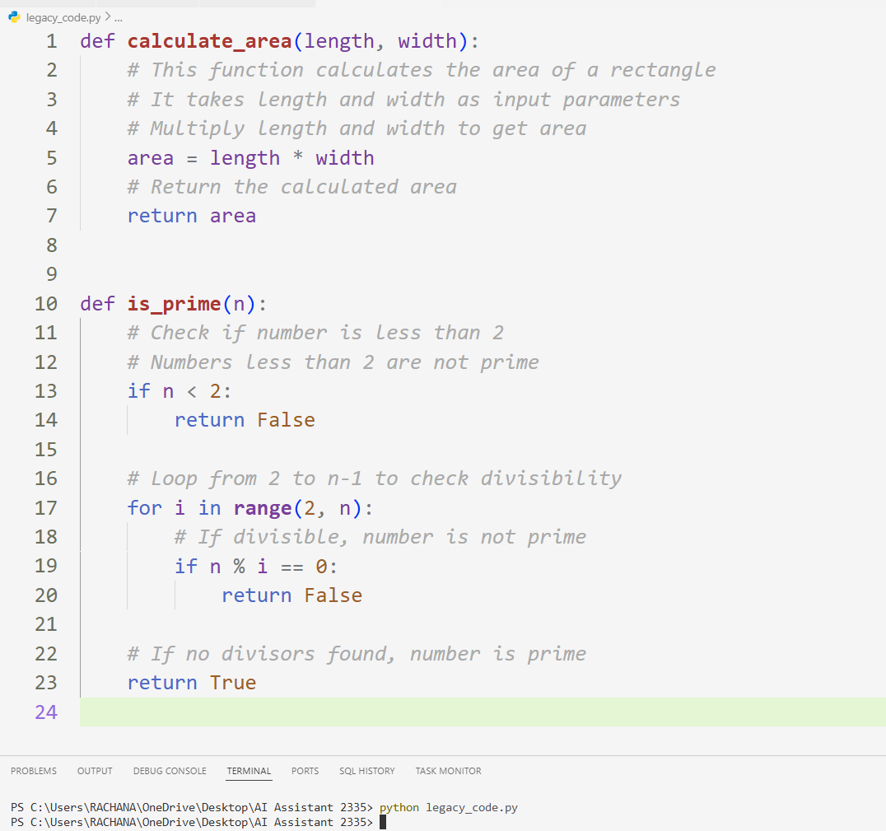

Prompt
Convert the explanatory inline comments in this Python code into
structured Google-style docstrings.
Requirements:
- Preserve original meaning of comments
- Move explanations into docstrings
- Remove redundant inline comments
- Keep only necessary logic comments if needed
- Improve readability and consistency
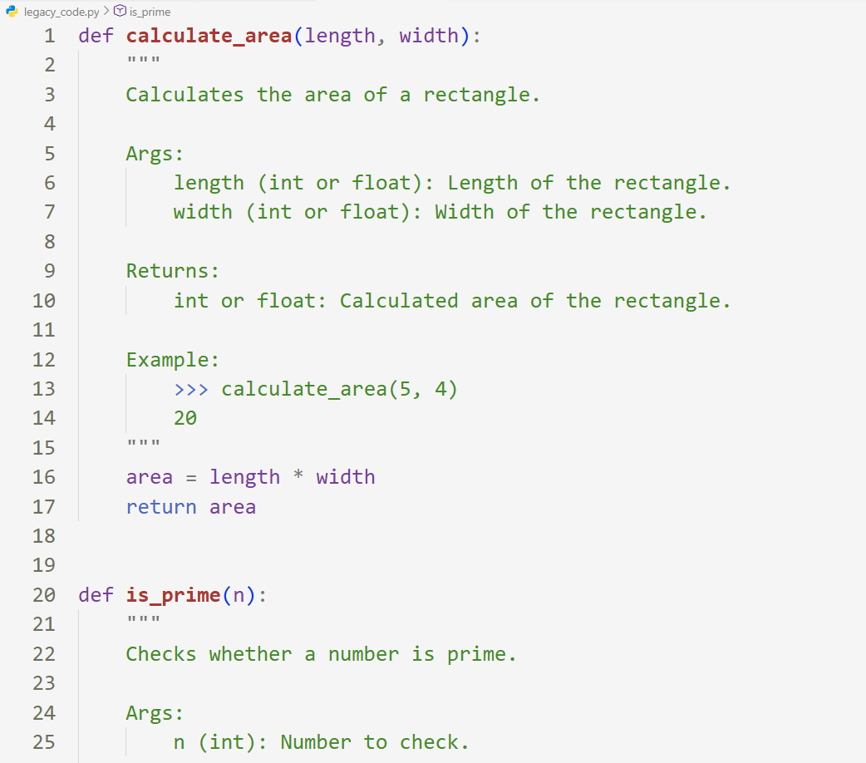
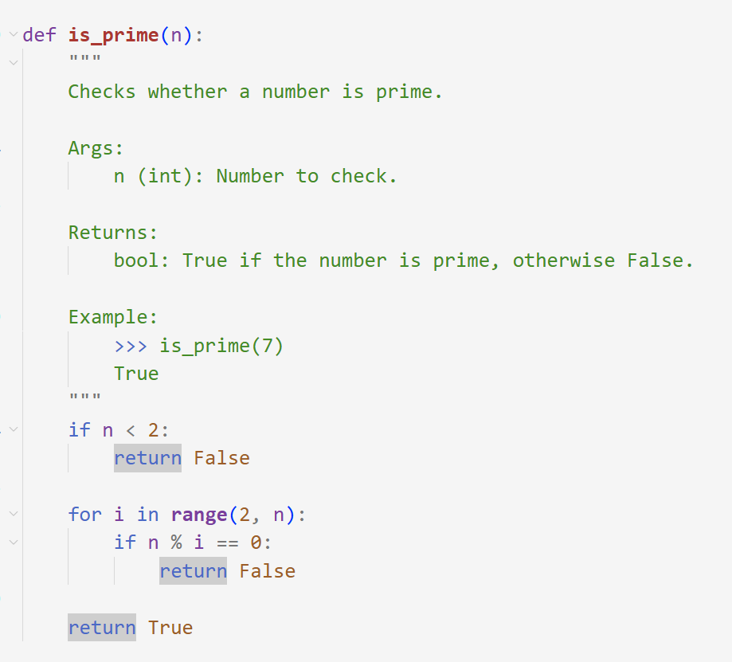
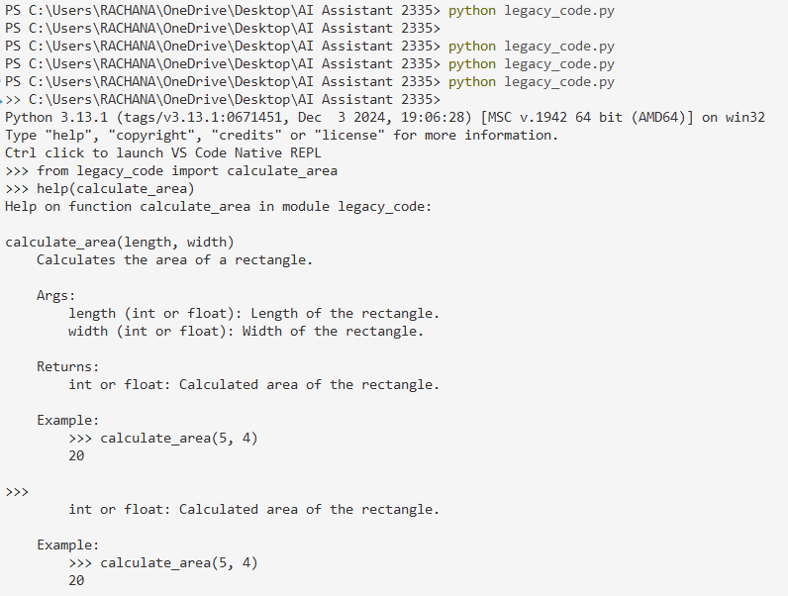
Observation:
- AI successfully converted inline developer comments into structured Google-style docstrings.
- Original meaning and logic explanations were preserved.
- Redundant comments inside function bodies were removed.
- Functions became cleaner and easier to read.
- Documentation consistency improved across the module.
Task 5: Building a Mini Automatic Documentation Generator
Scenario
Your team wants a simple internal tool that helps developers start
documenting new Python files quickly, without writing documentation
from scratch.
Task Description
Design a small Python utility that:
• Reads a given .py file
• Automatically detects:
o Functions
o Classes
• Inserts placeholder Google-style docstrings for each detected
function or class
AI tools may be used to assist in generating or refining this utility.
Note: The goal is documentation scaffolding, not perfect
documentation.
Expected Outcome
• A working Python script that processes another .py file
• Automatically inserted placeholder docstrings
• Clear demonstration of how AI can assist in documentation
Automation
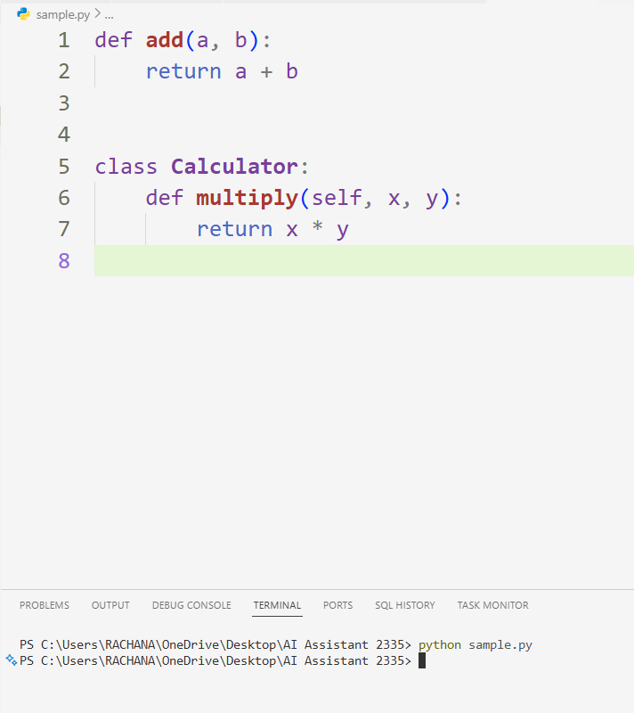
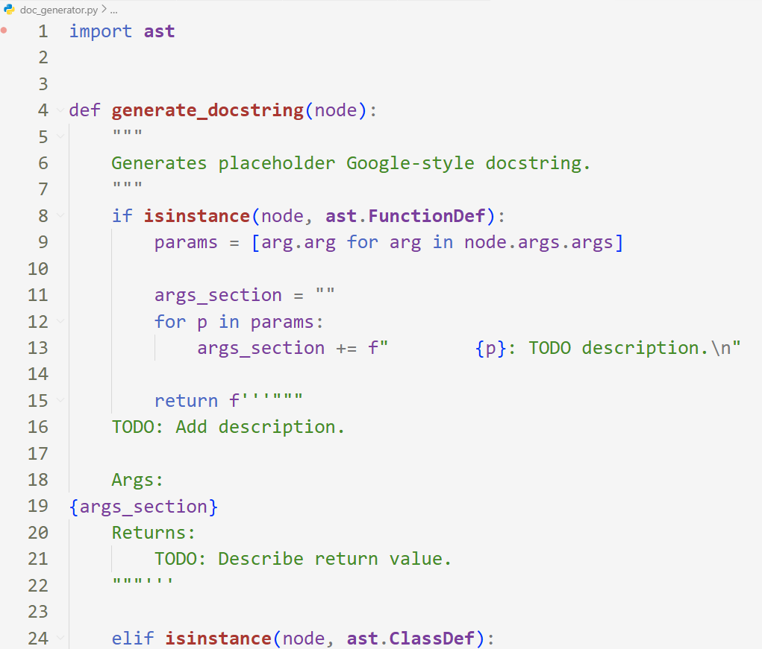
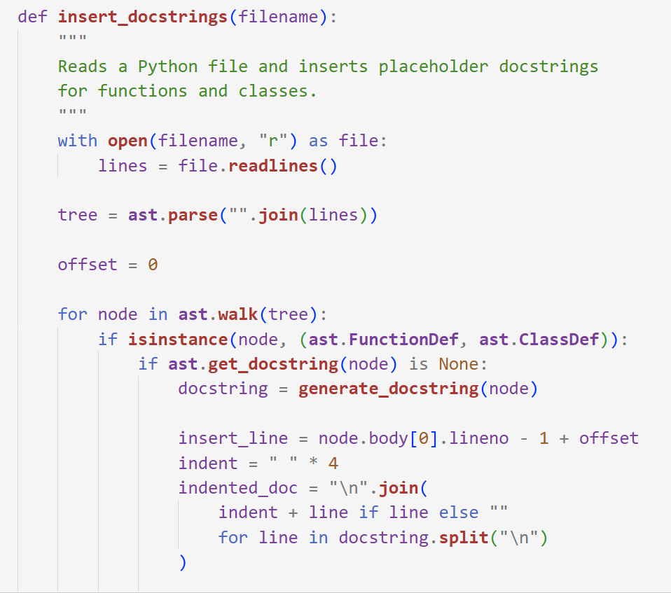
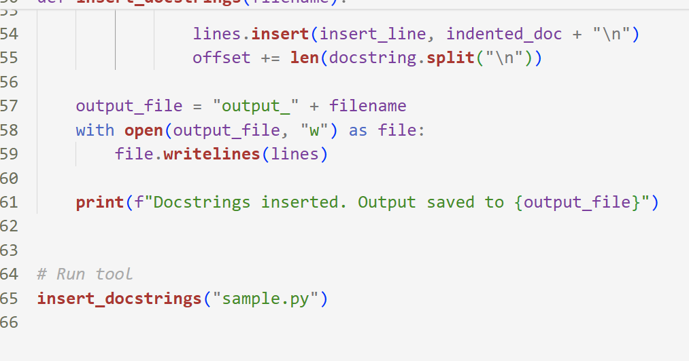
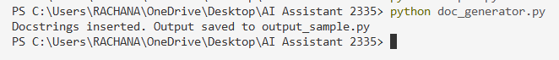
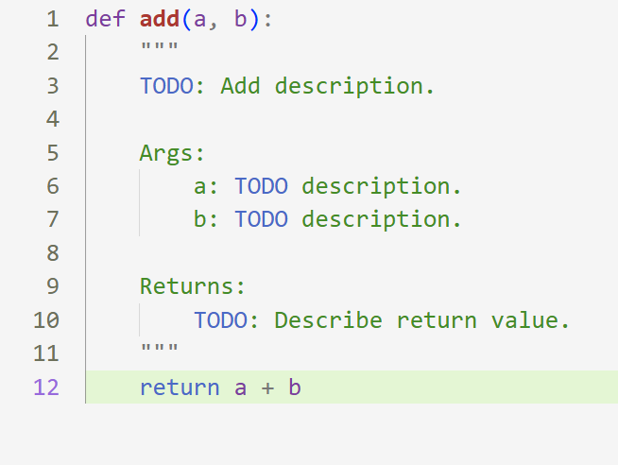
Example AI Prompt used:
Help me build a Python utility that reads a .py file,
detects functions and classes using AST,
and inserts placeholder Google-style docstrings automatically.
Observation:
- The script successfully detected functions and classes using Python AST.
- Placeholder Google-style docstrings were automatically inserted.
- Existing logic remained unchanged.
- Documentation scaffolding reduced manual effort.
- AI assistance helped design the automation logic quickly.

